Version cũ của website có thể xem tại: <http://drone.uzip.online/>

1. **Header**:

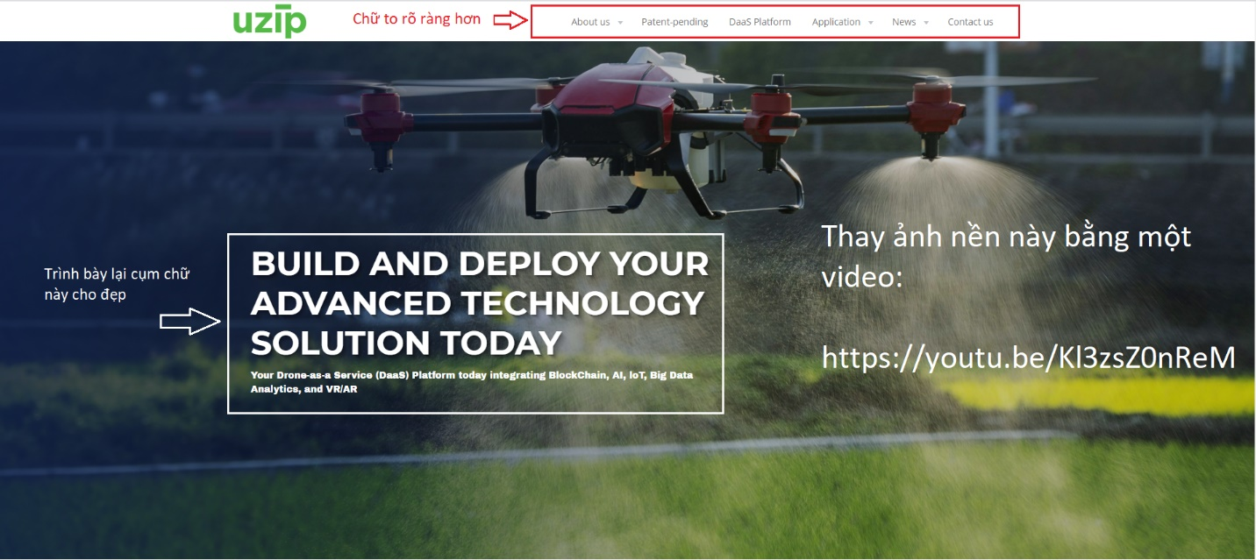

* Build and Deploy Your Advanced Technology Solution Today
* Your Drone-as-a-Service (DaaS) Platform today integrating BlockChain, AI, IoT, Big Data Analytics, and VR/AR
* Video: <https://youtu.be/Kl3zsZ0nReM>

Web mẫu có hiệu ứng video làm bìa:<https://enterprise.dji.com/?site=brandsite&from=nav>

1. **About Us**

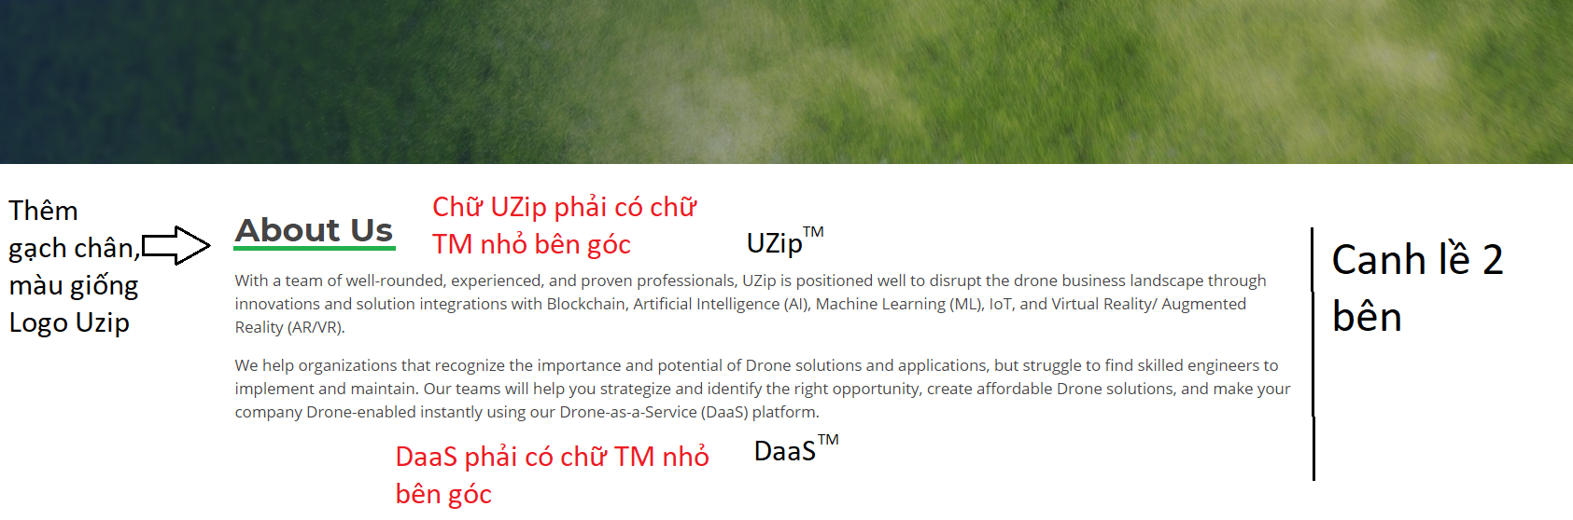

* With a team of well-rounded, experienced, and proven professionals, UZipTM is positioned well to disrupt the drone business landscape through innovations and solution integrations with Blockchain, Artificial Intelligence (AI), Machine Learning (ML), IoT, and Virtual Reality/ Augmented Reality (AR/VR).
* We help organizations that recognize the importance and potential of Drone solutions and applications, but struggle to find skilled engineers to implement and maintain. Our teams will help you strategize and identify the right opportunity, create affordable Drone solutions, and make your company Drone-enabled instantly using our Drone-as-a-Service (DaaSTM) platform.

1. **Patent-pending Technologies**

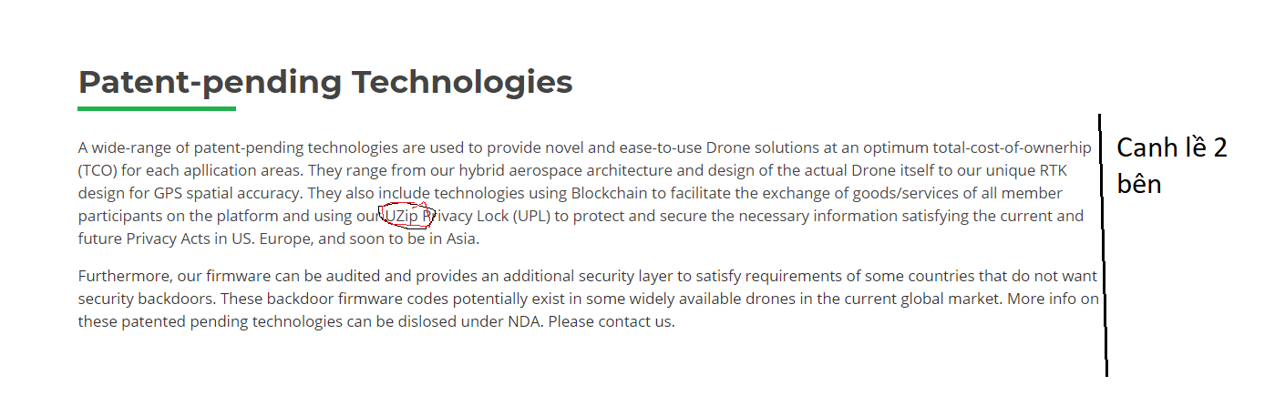

A wide-range of patent-pending technologies are used to provide novel and ease-to-use Drone solutions at an optimum total-cost-of-ownerhip (TCO) for each apllication areas. They range from our hybrid aerospace architecture and design of the actual Drone itself to our unique RTK design for GPS spatial accuracy. They also include technologies using Blockchain to facilitate the exchange of goods/services of all member participants on the platform and using our UZipTM Privacy Lock (UPL) to protect and secure the necessary information satisfying the current and future Privacy Acts in US. Europe, and soon to be in Asia.

Furthermore, our firmware can be audited and provides an additional security layer to satisfy requirements of some countries that do not want security backdoors. These backdoor firmware codes potentially exist in some widely available drones in the current global market. More info on these patented pending technologies can be dislosed under NDA. Please contact us.

1. **DaaSTM Platform**

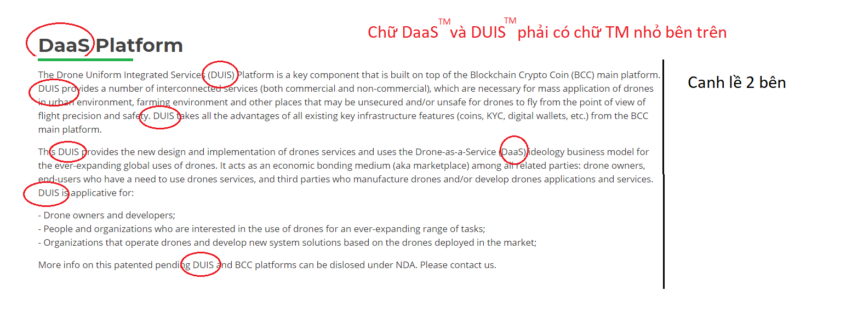

The Drone Uniform Integrated Services (DUISTM) Platform is a key component that is built on top of the Blockchain Crypto Coin (BCC) main platform. DUISTM provides a number of interconnected services (both commercial and non-commercial), which are necessary for mass application of drones in urban environment, farming environment and other places that may be unsecured and/or unsafe for drones to fly from the point of view of flight precision and safety. DUISTM takes all the advantages of all existing key infrastructure features (coins, KYC, digital wallets, etc.) from the BCC main platform.

This DUISTM provides the new design and implementation of drones services and uses the Drone-as-a-Service (DaaS) ideology business model for the ever-expanding global uses of drones. It acts as an economic bonding medium (aka marketplace) among all related parties: drone owners, end-users who have a need to use drones services, and third parties who manufacture drones and/or develop drones applications and services. DUIS is applicative for:

* Drone owners and developers;
* People and organizations who are interested in the use of drones for an ever-expanding range of tasks;
* Organizations that operate drones and develop new system solutions based on the drones deployed in the market.

More info on this patented pending DUISTM and BCC platforms can be dislosed under NDA. Please contact us.

1. **Drone use in farming and agriculture**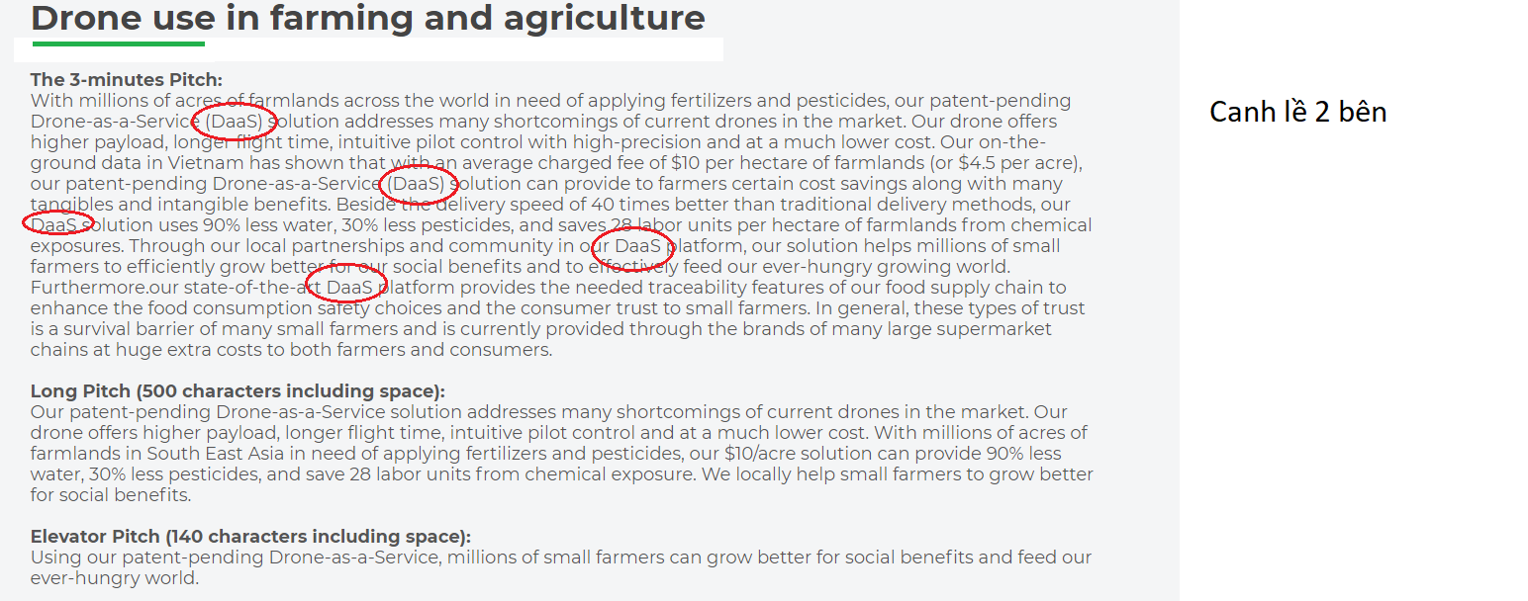

**The 3-minutes Pitch:**

With millions of acres of farmlands across the world in need of applying fertilizers and pesticides, our patent-pending Drone-as-a-Service (DaaSTM) solution addresses many shortcomings of current drones in the market. Our drone offers higher payload, longer flight time, intuitive pilot control with high-precision and at a much lower cost. Our on-the-ground data in Vietnam has shown that with an average charged fee of $10 per hectare of farmlands (or $4.5 per acre), our patent-pending Drone-as-a-Service (DaaSTM) solution can provide to farmers certain cost savings along with many tangibles and intangible benefits. Beside the delivery speed of 40 times better than traditional delivery methods, our DaaSTM solution uses 90% less water, 30% less pesticides, and saves 28 labor units per hectare of farmlands from chemical exposures. Through our local partnerships and community in our DaaSTM platform, our solution helps millions of small farmers to efficiently grow better for our social benefits and to effectively feed our ever-hungry growing world. Furthermore.our state-of-the-art DaaS platform provides the needed traceability features of our food supply chain to enhance the food consumption safety choices and the consumer trust to small farmers. In general, these types of trust is a survival barrier of many small farmers and is currently provided through the brands of many large supermarket chains at huge extra costs to both farmers and consumers.

**Long Pitch (500 characters including space):**

Our patent-pending Drone-as-a-Service solution addresses many shortcomings of current drones in the market. Our drone offers higher payload, longer flight time, intuitive pilot control and at a much lower cost. With millions of acres of farmlands in South East Asia in need of applying fertilizers and pesticides, our $10/acre solution can provide 90% less water, 30% less pesticides, and save 28 labor units from chemical exposure. We locally help small farmers to grow better for social benefits.

**Elevator Pitch (140 characters including space):**

Using our patent-pending Drone-as-a-Service, millions of small farmers can grow better for social benefits and feed our ever-hungry world.

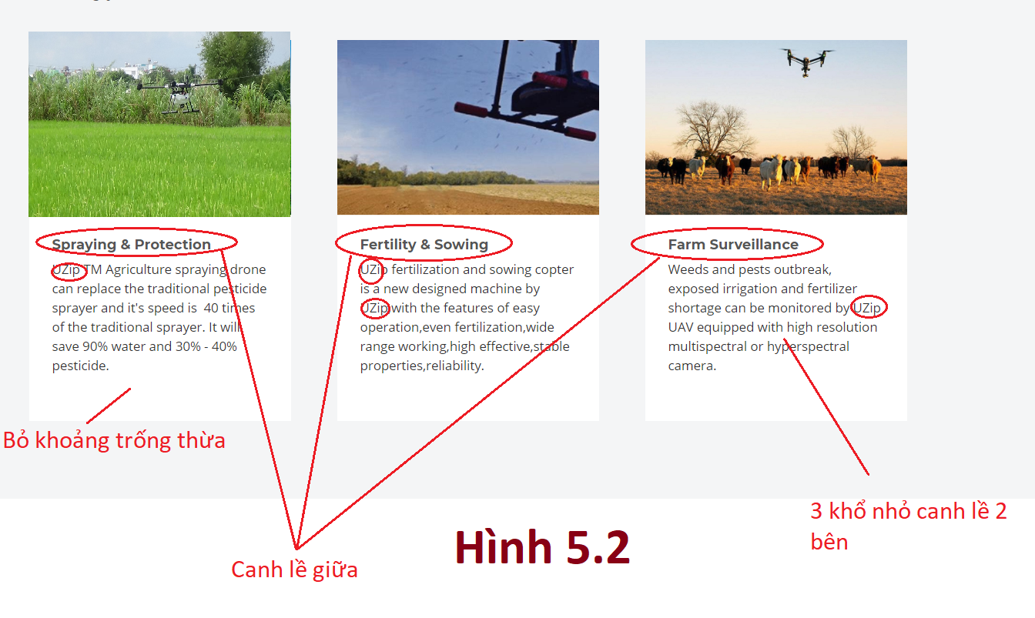

**Spraying & Protection**

UZipTM Agriculture spraying drone can replace the traditional pesticide sprayer and it's speed is 40times of the traditional sprayer. It will save 90% water and 30%-40% pesticide.

**Fertility & Sowing**

UZipTM fertilization and sowing copter is a new designed machine by UZipTM,with the features of easy operation,even fertilization,wide range working,high eﬀective,stable properties,reliability.

**Farm Surveillance**

Weeds and pests outbreak, exposed irrigation and fertilizer shortage can be monitored by UZipTM UAV equipped with high resolution multispectral or hyperspectral camera.

1. **Drone use in Business**

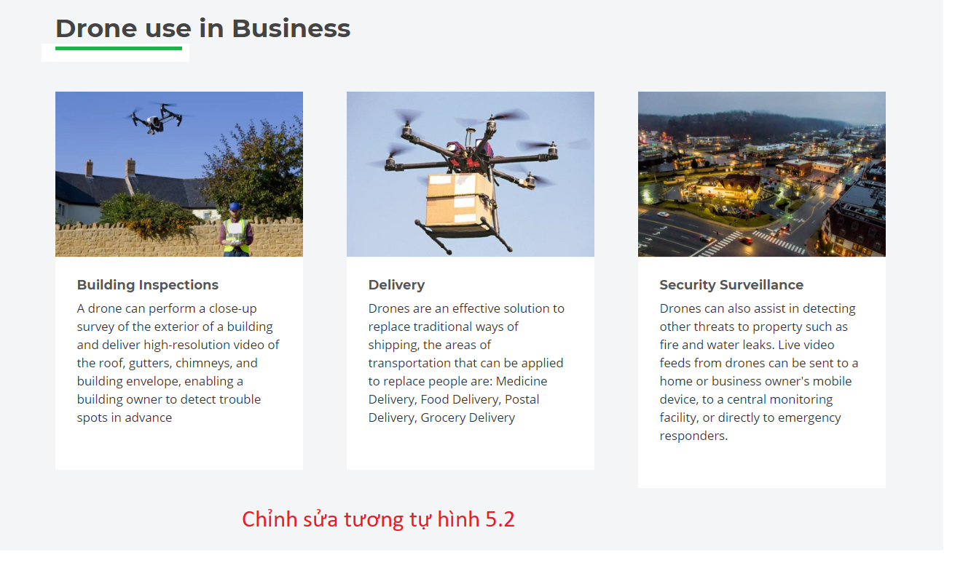

**Building Inspections**

A drone can perform a close-up survey of the exterior of a building and deliver high-resolution video of the roof, gutters, chimneys, and building envelope, enabling a building owner to detect trouble spots in advance.

**Delivery**

Drones are an effective solution to replace traditional ways of shipping, the areas of transportation that can be applied to replace people are: Medicine Delivery, Food Delivery, Postal Delivery, Grocery Delivery

**Security Surveillance**

Drones can also assist in detecting other threats to property such as fire and water leaks. Live video feeds from drones can be sent to a home or business owner's mobile device, to a central monitoring facility, or directly to emergency responders.

1. **Drone use in military**

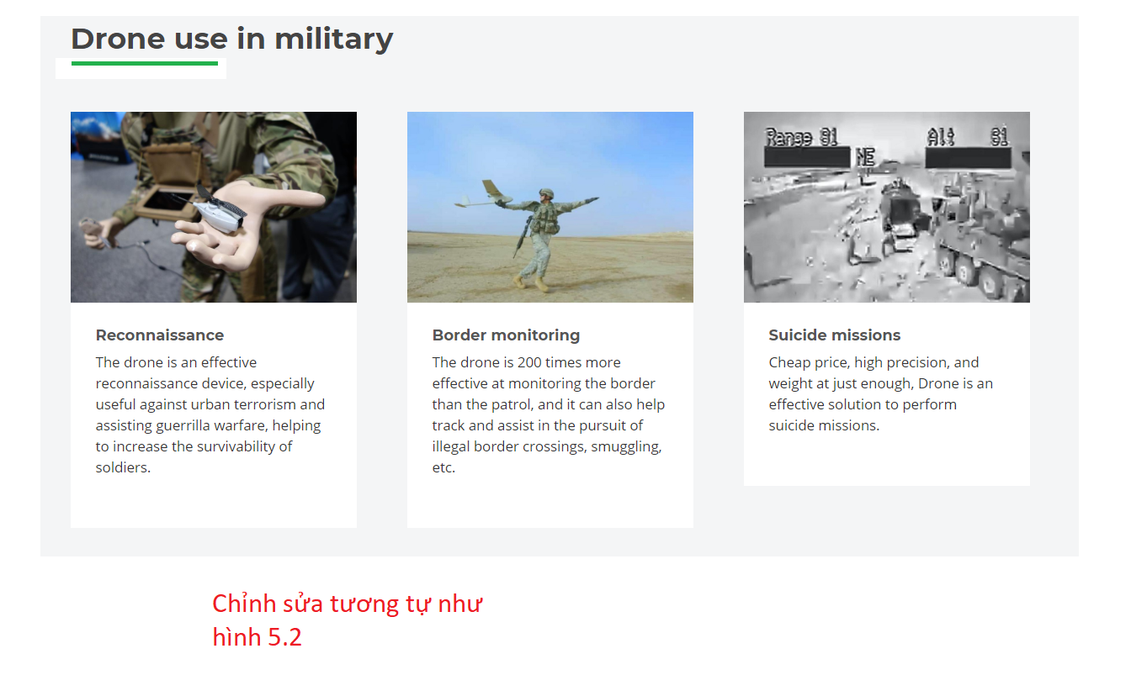

**Reconnaissance**

The drone is an effective reconnaissance device, especially useful against urban terrorism and assisting guerrilla warfare, helping to increase the survivability of soldiers.

**Border monitoring**

The drone is 200 times more effective at monitoring the border than the patrol, and it can also help track and assist in the pursuit of illegal border crossings, smuggling, etc.

**Suicide missions**

Cheap price, high precision, and weight at just enough, Drone is an effective solution to perform suicide missions.

1. **Drone use in other areas**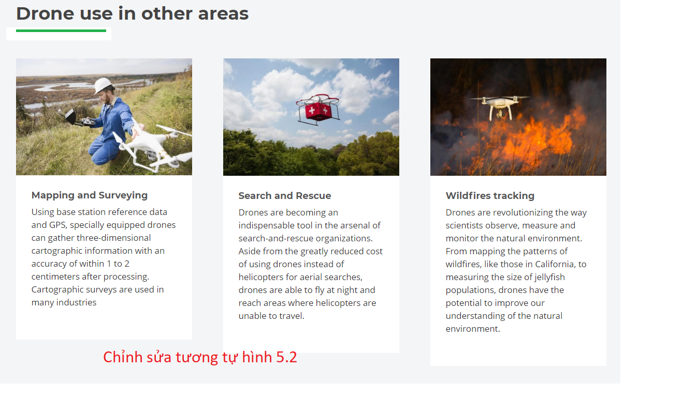

**Mapping and Surveying**

Using base station reference data and GPS, specially equipped drones can gather three-dimensional cartographic information with an accuracy of within 1 to 2 centimeters after processing. Cartographic surveys are used in many industries.

**Search and Rescue**

Drones are becoming an indispensable tool in the arsenal of search-and-rescue organizations. Aside from the greatly reduced cost of using drones instead of helicopters for aerial searches, drones are able to fly at night and reach areas where helicopters are unable to travel.

**Wildfires tracking**

Drones are revolutionizing the way scientists observe, measure and monitor the natural environment. From mapping the patterns of wildfires, like those in California, to measuring the size of jellyfish populations, drones have the potential to improve our understanding of the natural environment.

1. **Management team**

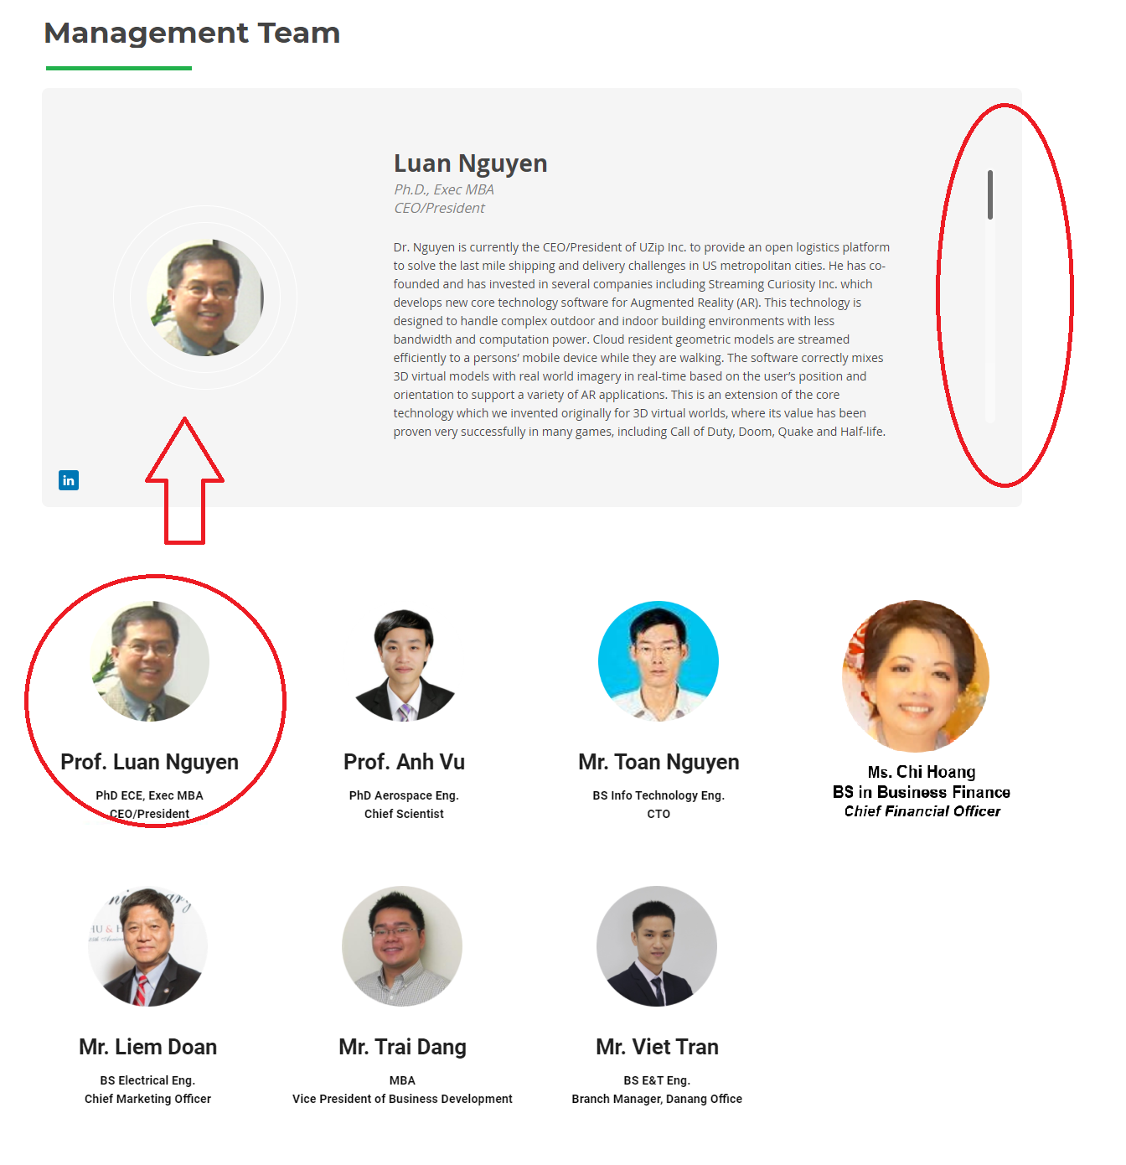

Lay out như hình trên

* Phần 1: Hiển thị thông tin chi tiết mỗi cá nhân được chọn, nếu nhiều thông tin quá thì cần thanh trượt dọc để đọc, ít thông tin thì scale kích thước Box này cho phù hợp để đệp mắt
* Phần 2:
  + List danh sách Management team
  + Sử dụng hình ảnh xám của mỗi người, lấy tại thư mục **Management_Team** gởi kèm
  + Click vào người nào thì thông tin chi tiết của họ được update lên Phần 1. Thông tin chi tiết của mỗi người lấy tại file **Management Team.pptx** gởi kèm
* Tham khảo Website <http://uzip.online/> để thấy rõ hơn về chức năng này.

1. **Advisors**



* Làm tương tự như Management team
* Sử dụng ảnh xám của các Advisor tại thư mục **Advisors** gởi kèm
* Thông tin về các Advisor lấy tại file **Advisors.pptx** gởi kèm

1. Footer

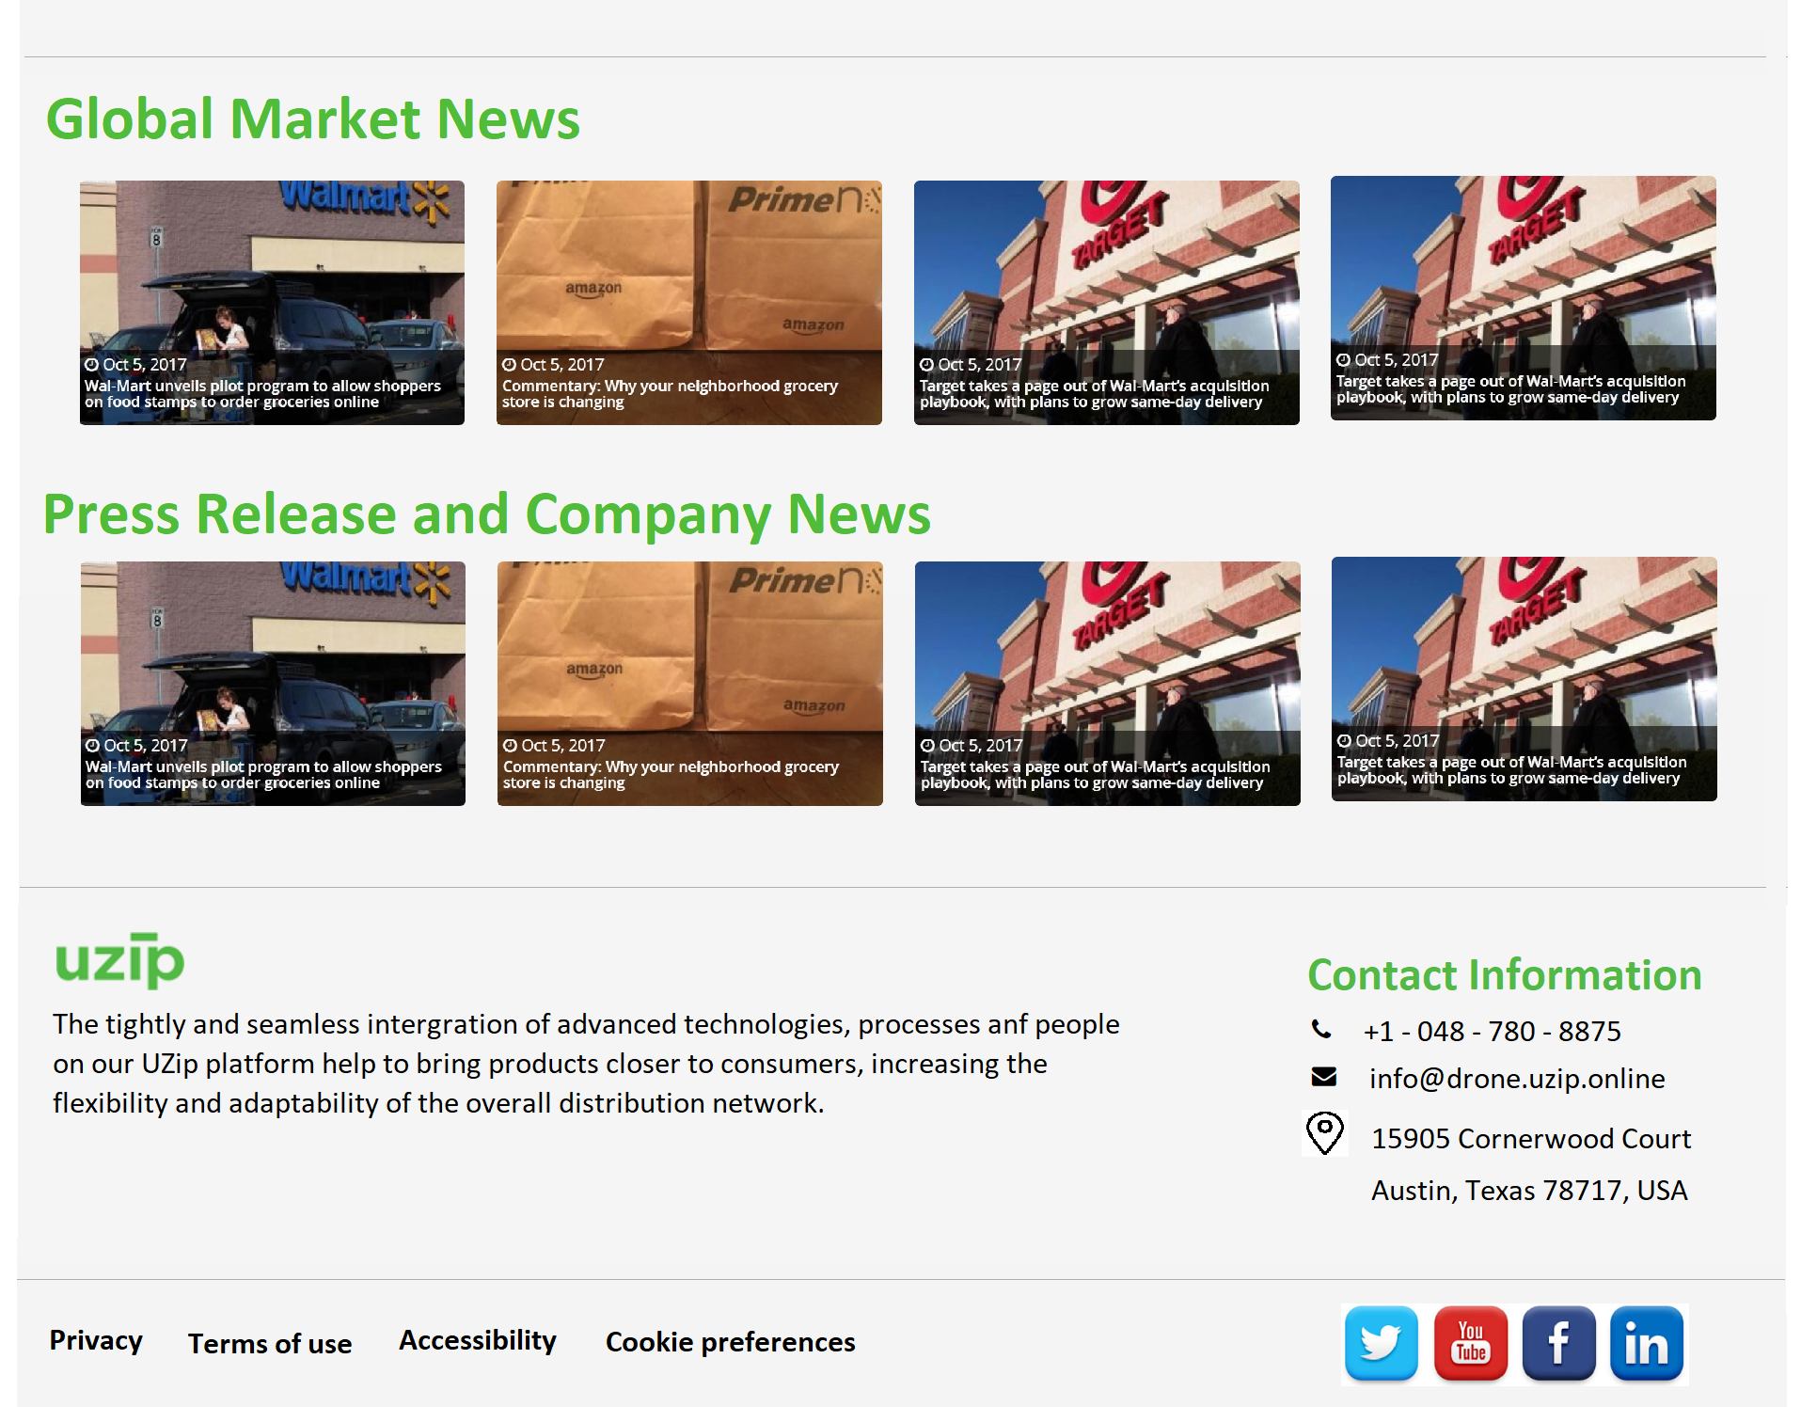

Chia làm 4 phần:

* Phần 1: Global Market News

Liên kết đến 4 blog thị trường

+ <https://dronelife.com/>

+ <https://www.spacewar.com/uav.html>

+ <https://www.dronedeploy.com/blog/>

+ <http://www.aero-news.net/>

* Phần 2: Press Release and Company News

Liên kết đến 4 bài báo của công ty:

+ <https://vnexpress.net/giao-duc/pho-giao-su-che-tao-may-bay-phun-thuoctru-sau-4053608.html>

+ <https://video.vnexpress.net/tin-tuc/thoi-su/thay-giao-tp-hcm-che-tao-maybay-dieu-khien-phun-thuoc-tru-sau-3706949.html>

+ <https://dantri.com.vn/giao-duc-khuyen-hoc/pho-giao-su-37-tuoi-che-taomay-bay-danh-cho-nha-nong-20200126133650407.htm>

+ <https://www.facebook.com/847372608751026/videos/485327812136341/>

* Phần 3: hiển thị giới thiệu và thông tin liên hệ của UZip

The tightly and seamless intergration of advanced technologies, processes anf people on our UZip platform help to bring products closer to consumers, increasing the flexibility and adaptability of the overall distribution network.

* + Contact Information
    - +1 - 048 - 780 - 8875
    - info@drone.uzip.online
    - US Address: 15905 Cornerwood Court, Austin, Texas 78717, USA
* Phần 4: Thanh chức năng
  + Privacy: bấm vào đây thì nhảy sang trang con hiển thị nội dung file **Privacy.docx** gởi kèm
  + Terms of use: bấm vào đây thì nhảy sang trang con hiển thị nội dung file **Terms of use.docx** gởi kèm
  + Accessibility: bấm vào đây thì nhảy sang trang con hiển thị nội dung file **Accessibility.docx** gởi kèm
  + Cookie preferences: bấm vào đây thì nhảy sang trang con hiển thị nội dung file **Cookie preferences.docx** gởi kèm
  + Các nút chức năng liên kết tới Social Network



Youtube: <https://www.youtube.com/channel/UCNYFXal7ViqPA7G-gYwIvkQ/>

Facebook: <https://www.facebook.com/JWCLab/?eid=ARBw6hX88mhvyE-pq9cE7xzH-khh7bMPVjnqcAZ9vL-PZzvoGNzIY6CVaugeY4PGxGoZ6ZnJyOIoTa88>

1. Chức năng của Tab bar

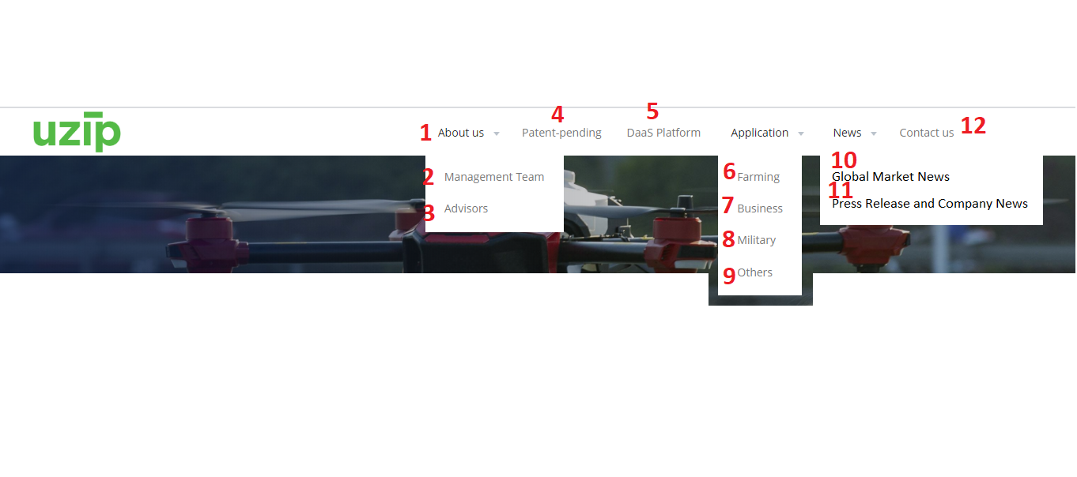

* Click vào vị trí 1: nhảy tới mục 2 trong tài liệu
* Click vào vị trí 2: nhảy tới mục 9 trong tài liệu
* Click vào vị trí 3: nhảy tới mục 10 trong tài liệu
* Click vào vị trí 4: nhảy tới mục 3 trong tài liệu
* Click vào vị trí 5: nhảy tới mục 4 trong tài liệu
* Click vào vị trí 6: nhảy tới mục 5 trong tài liệu
* Click vào vị trí 7: nhảy tới mục 6 trong tài liệu
* Click vào vị trí 8: nhảy tới mục 7 trong tài liệu
* Click vào vị trí 9: nhảy tới mục 8 trong tài liệu
* Click vào vị trí 10: nhảy tới phần 1 mục 11 trong tài liệu
* Click vào vị trí 11: nhảy tới phần 2 mục 11 trong tài liệu
* Click vào vị trí 12: nhảy tới phần 3 mục 11 trong tài liệu

1. Chức năng của Download tài liệu:

* Website cầ hỗ trợ người dùng đăng nhập với user/password
* Trong các mục liệt kê bên trên, có thể gắn nút vào trong các van bản, mỗi nút download này sẽ liên kết tới một số tài liệu nhất định.
* Khi người dùng đăng nhập user/password thì được phép down load các tài liệu này.
* Người dùng không đăng nhập thì hiển thị thông báo “You need to log in to download this document”